

Dr. Patrick, Vazquez inc.

2024-12-29

Dr. Vazquez

850 Powell Center Apt. 318, Rodriguezfort, CT 68587

Phone: 705939885

Fax: 7864709092

**Re:** Allison, Moore

**PHN:** 557641573

**Birthdate:** 23-Aug-1945

**Address:** USNV Smith, FPO AA 82926

**Patient number:** 7128360003

To Whom It May Concern:

This is a medical letter to state the above patient is pregnant with expected delivery date of 03-Sep-2025. Hoping this information is satisfactory for your requirements.

Thank you.

Sincerely,

Dr. Patrick, Vazquez

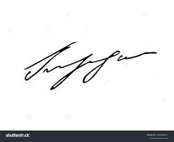

FRCS© NCMP

Clinical Assistant Professor, UBC

Department of Obstetrics and Gynecology SMH